Experiment No.: Date:

Title: To establish a TELNET session
Learning Objectives: At the end of this experiment, students will be able to:
- Configure RIP (Routing Information Protocol)
- Remotely login the router using TELNET
Pre-requisite: Basic concepts of routing protocol
Apparatus: Cisco Packet Tracer
Theory:

TELNET (TELEcommunication NETwork)
Telnet is an application protocol used on the Internet or local area networks to provide a bidirectional interactive text-oriented eight-bit/ byte communication facility using a virtual terminal connection over the Transmission Control Protocol (TCP).
A Telnet program allows a user on one system to login to a remote system and issue commands in a command window of the remote system
Telnet offers three basic services :
1. It defines a network virtual terminal that provides a standard interface to remote systems.
2. Telnet includes a mechanism that allows the client and server to negotiate options .
3. Telnet treats both ends of the connection symmetrically.

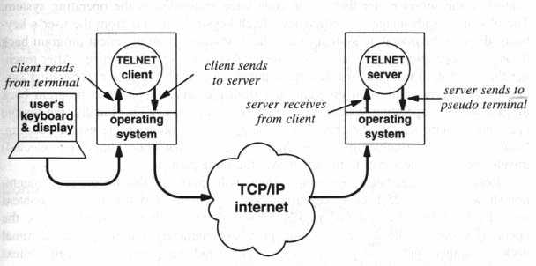

Figure : TELNET session establishment

RIP(Routing Information Protocol)
Routing Information Protocol (RIP) is a standards-based, distance-vector, interior gateway protocol (IGP) used by routers to exchange routing information. RIP uses hop count to determine the best path between two locations. Hop count is the number of routers the packet must go through till it reaches the destination network. The maximum allowable number of hops a packet can traverse in an IP network implementing RIP is 15 hops.
it has a maximum allowable hop count of 15 by default, meaning that 16 is deemed unreachable. RIP works well in small networks, but it's inefficient on large networks with slow WAN links or on networks with a large number of routers installed.
In a RIP network, each router broadcasts its entire RIP table to its neighbouring routers every 30 seconds. When a router receives a neighbour's RIP table, it uses the information provided to update its own routing table and then sends the updated table to its neighbours.

Procedure :
1) Wire all of the devices in the network, make sure routers need to be connected to each other over serial connections.
2) Configure the ip addressing of all of the devices
3) Configure the devices using CLI commands
4) Configure RIP so all devices can communicate over the network,
5) Verify that all PCs can communicate with each other over the network
6) Enter commands in CLI window of routers to establish a TELNET session
7) Enter commands in command window of PC to check whether TELNET session has been properly established

Result and Discussion:

Conclusion:

